**Week -2 TDD using Junit and Mockito Mandatory HandsOn Solutions**

Exercise 1: Setting Up Junit

**Source code:**

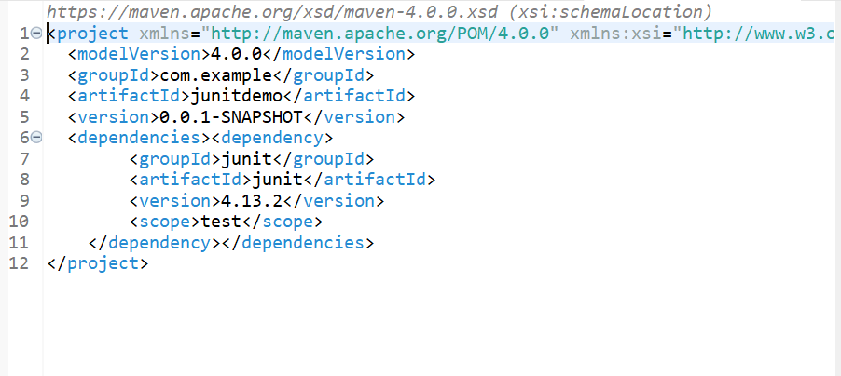

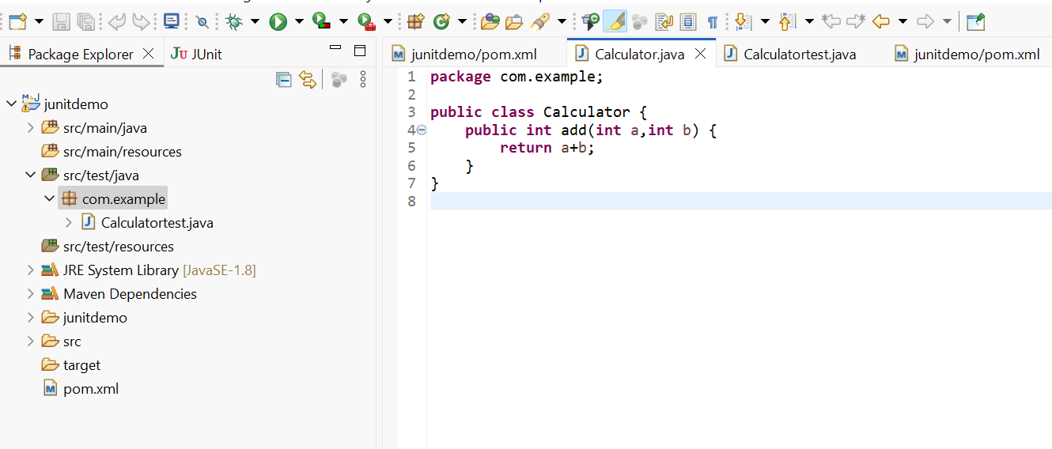

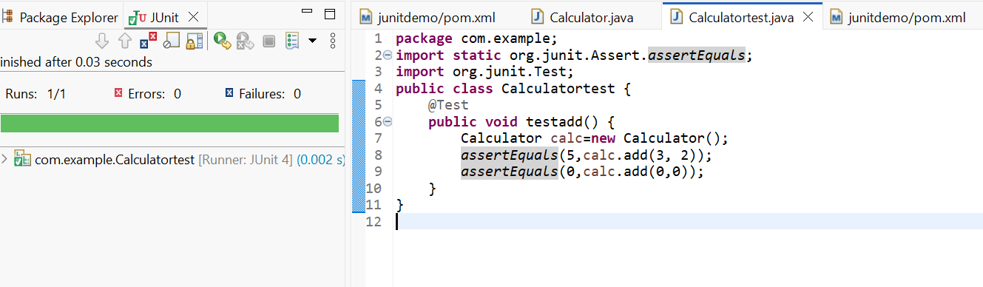

Exercise 3: Assertions in JUnit

Scenario: You need to use different assertions in JUnit to validate your test results.

**Source Code**:

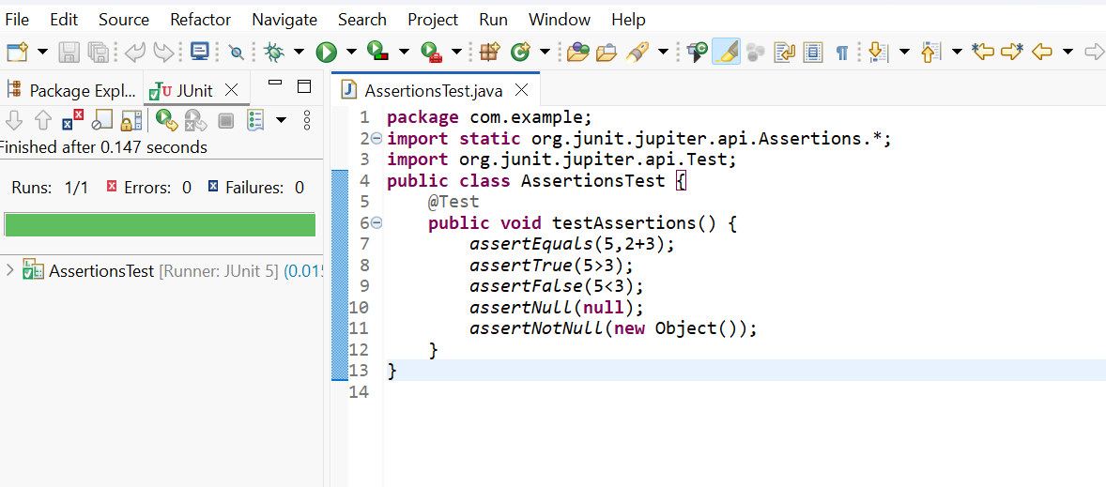

Exercise 4: Arrange-Act-Assert (AAA) Pattern, Test Fixtures, Setup and Teardown Methods in JUnit

Scenario: You need to organize your tests using the Arrange-Act-Assert (AAA) pattern and use setup and teardown methods.

**Source Code**:

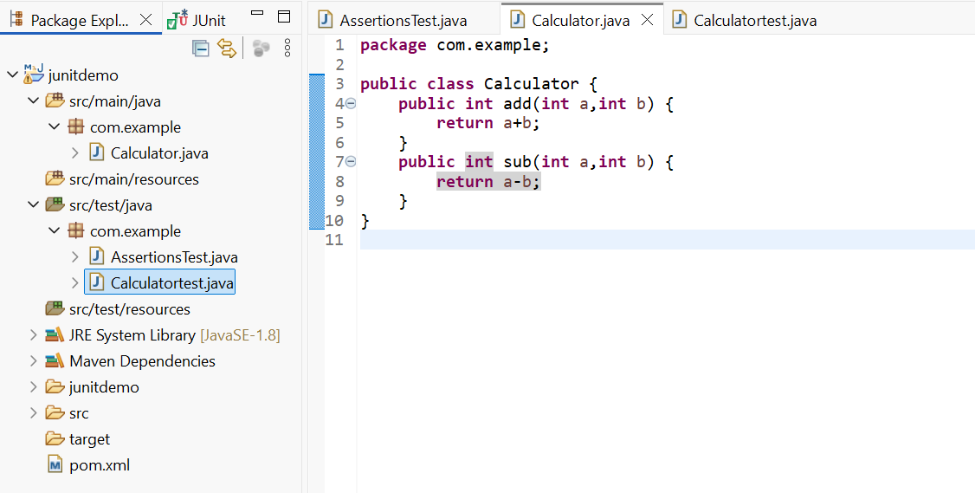

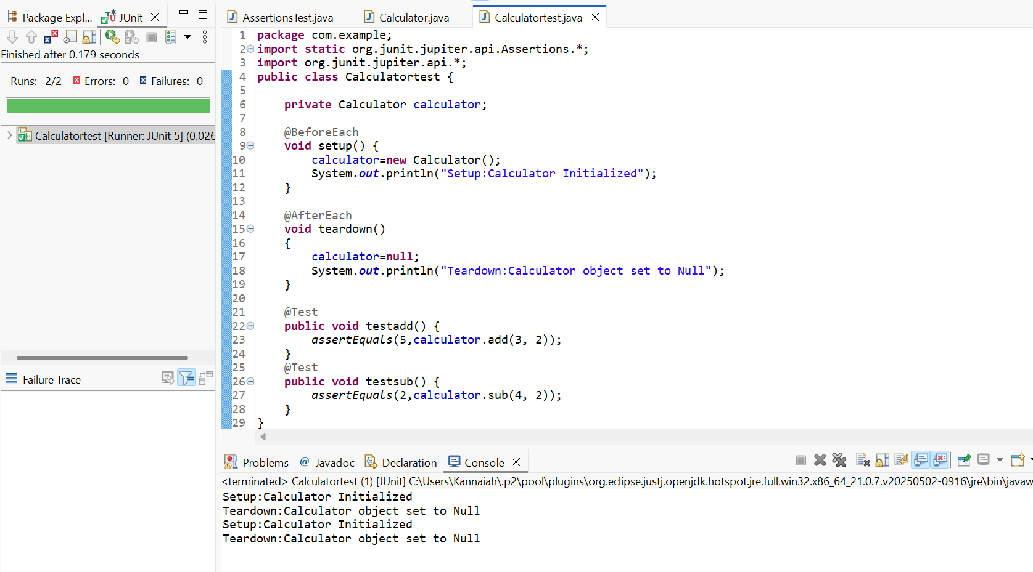

**Mockito Mandatory Hands-On Exercises Solutions.**

Exercise 1: Mocking and Stubbing

Scenario: You need to test a service that depends on an external API. Use Mockito to mock the external API and stub its methods.

**Steps**:

1. Create a mock object for the external API.

2. Stub the methods to return predefined values.

3. Write a test case that uses the mock object.

**Source Code**:

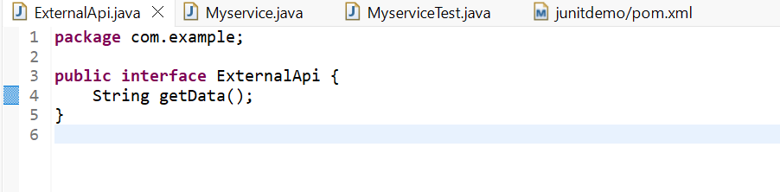

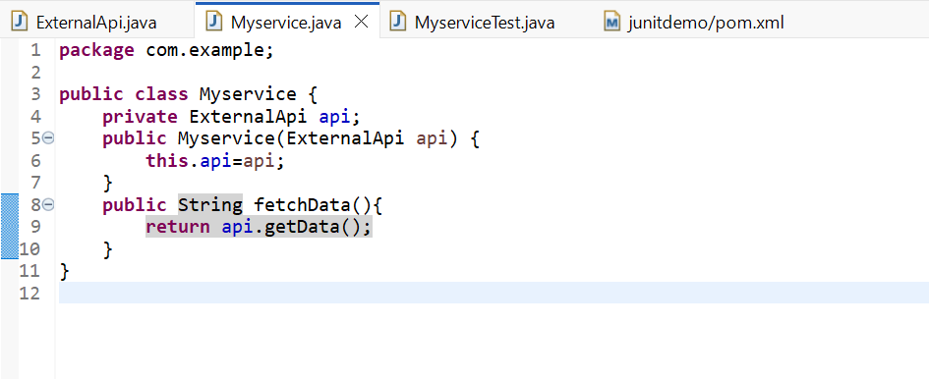

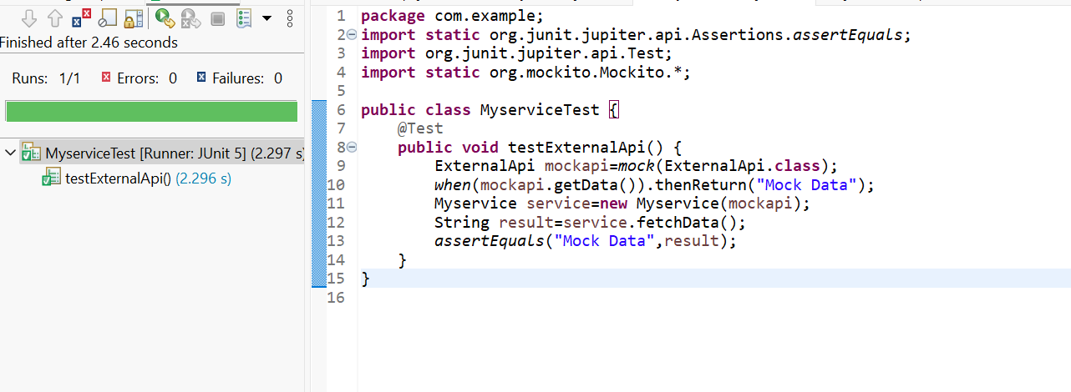

Exercise 2: Verifying Interactions

Scenario: You need to ensure that a method is called with specific arguments.

**Steps**:

1. Create a mock object.

2. Call the method with specific arguments.

3. Verify the interaction.

**Source Code**:





